1. Design below table

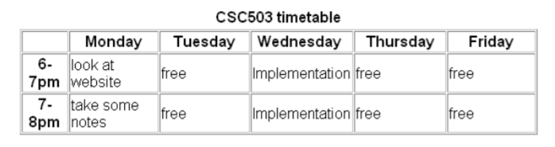

1. Design the below table

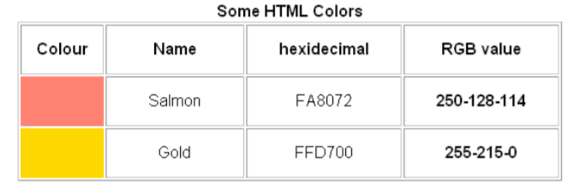

1. Use Row span and design the below table

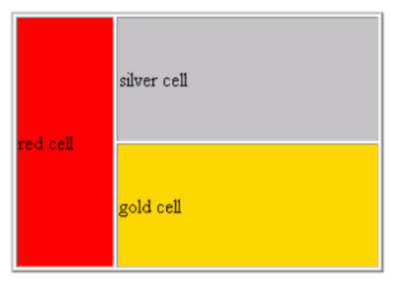

1. Use colspan, cellspacing and cellpadding

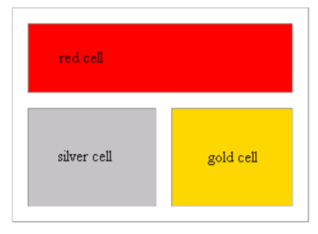

1. Design the below table

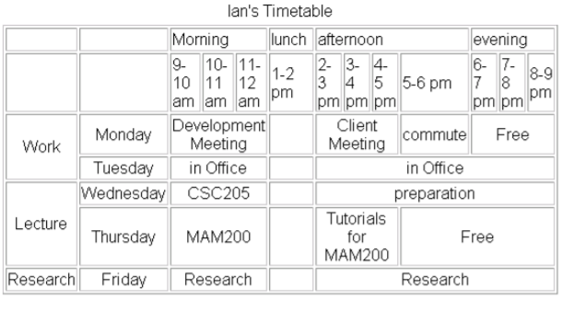

1. Design the below table

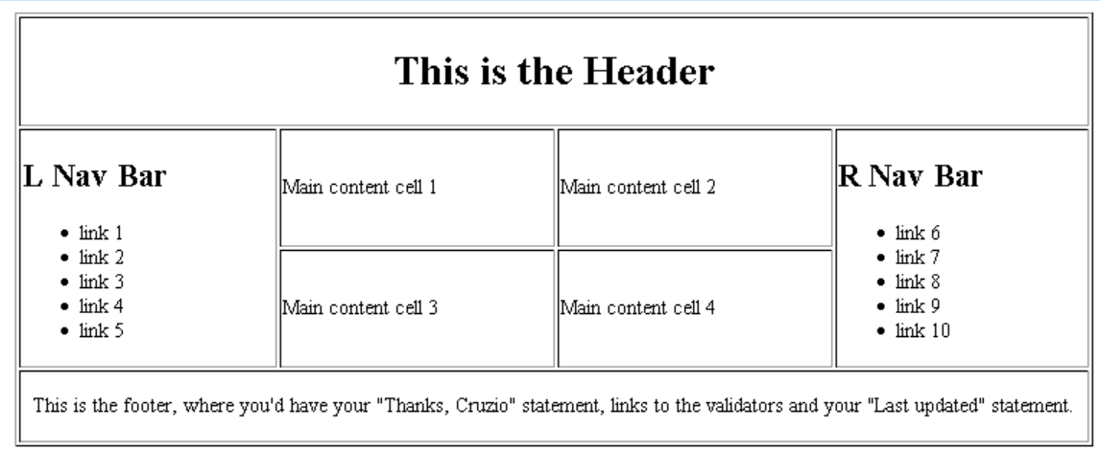

1. Choose some images and create your image grid using table.

